Online Resources
VITAL WorkLife EAP
Online Resources
VITAL WorkLife provides a robust website where you can go 24 hours a day, 7 days a week for help with everything from child and eldercare concerns, to finding good pet care or a good contractor, to dealing with health and relationship issues, achieving emotional well being and more.

Well Being Articles
We have hundreds of articles on a wide range of topics available on our blog at VITALWorkLife.com, just click on Insights.

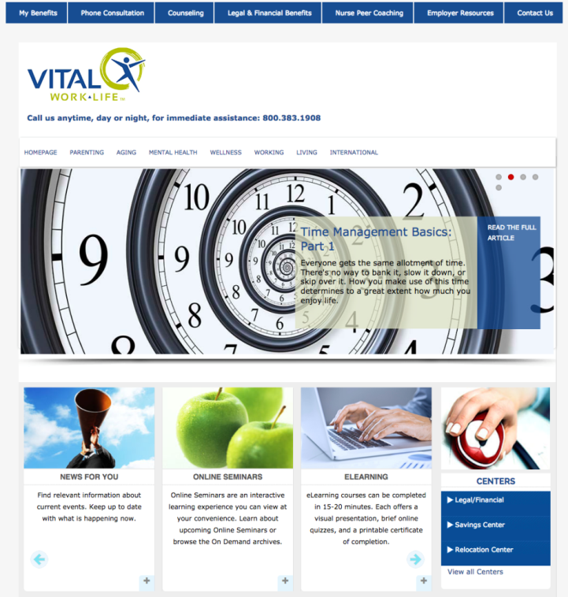
Member Website
Your member website is an online portal allowing you to access detailed benefit information and a wealth of online resources.

How to Access Your Member Website
- Log in to your Member Website at VITALWorkLife.com/member-login.
Username: username
Password: member
Online Work & Life Resources: A comprehensive library of support topics including parenting, wellness, career development, consumer tips and more. Click on topics in the category menu to begin exploring this library of informative and valuable articles, assessments, audio files, calculators, checklists, glossaries and resource links.
Online Seminars: On-demand learning on a wide range of topics; browse topics by clicking the plus sign in the Online Seminar box on your member homepage.
eLearning Courses: On-demand training on many topics. These eLearning courses can be completed in 15-20 minutes, include a visual presentation, brief online quiz and a printable certificate of completion. Click the plus sign in the eLearning box on your member homepage to select a course.
Online Legal & Financial Resources: Unlimited access to a wealth of financial and legal resources on your member website. You'll find tip sheets, calculators, handbooks, online seminars, worksheets and checklists, legal forms and more. Just click Legal & Financial Benefits at the top of your member website to begin exploring resources.

If you have questions or need assistance, please contact us anytime, day or night, at 800.383.1908
30-006-0218

