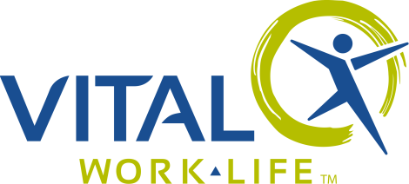

## EAP Contact Information

VITAL WorkLife

800.383.1908

[**VITALWorkLife.com**](http://vitalworklife.com/)

Username: username

Password: member

## EAP Overview

[Orientation Video](http://info.vitalworklife.com/eap-orientation-link)

## Document Links

[EAP Fast Facts](http://info.vitalworklife.com/hubfs/Client_Materials-Documents-Flyers-Handouts/EAP_Engagement_Kit/EAP_Fast_Facts.pdf)

[50 Ways to Use Your EAP](http://info.vitalworklife.com/hubfs/Client_Materials-Documents-Flyers-Handouts/EAP_Engagement_Kit/50_Ways_to_use_your_EAP.pdf)

[VITAL WorkLife EAP Flyer](http://info.vitalworklife.com/hubfs/Client_Materials-Documents-Flyers-Handouts/EAP_Engagement_Kit/Flyer-EAP_General.pdf)

# Employee Assistance Program

Your EAP provider, VITAL WorkLife, offers free and confidential counseling, online and other resources to help address all dimensions of your well being – professional, physical, relational, financial/legal, spiritual and emotional.

**Counseling & Coaching Services – Pathways to Well Being**

VITAL WorkLife can help you and your family, both personally and professionally.   
Your EAP benefit can be accessed 24 hours a day, 7 days a week and includes:

* Face-to-face sessions per incident
* Unlimited telephonic counseling
* Legal and financial consultation
* Member portal with articles, seminars, self-paced training and more

**VITAL WorkLife can help with a wide variety of concerns:**

|  |  |
| --- | --- |
| * Marital and relationship difficulties | * Legal and Financial problems |
| * Parenting and child concerns | * Grief and loss |
| * Depression, stress and anxiety | * Interpersonal conflict – at work or home |
| * Anger | * Work/life balance |
| * Drug and alcohol abuse | * Supervisor Consultation |
| * Maintaining sobriety | * And much more |

## Getting help is easy:

* Call 800.383.1908 or
* Go to VITALWorkLife.com, click on “Member Login” and enter your username and password

Let VITAL WorkLife help you build Pathways to Well Being.